
By: Ghulam Mustafa
Cms : 023-24-0513
Assigned by: Sir Muhammad Faiz
Class BS(CS)-III
oct 1, 2025
Data Structure

Table of Contents
• Algorithm to Traverse elements from an Array:- 6
• Algorithm to search location of desired element from an Array:- 7
• Time Complexity of Algorithms:- 8
• Algorithm to search location of largest element from an Array:- 8
• Binary search:- 10
• Algorithm to search desired element from an Array(Binary Search):- 10
• Algorithm to insert desired element in an Array:- 11
• Algorithm to delete desired element in an Array:- 12
• Sorting:- 13
• Algorithm to sort an Array through Bubble Sort:- 14
• Algorithm to sort an Array through Selection Sort:- 16
• Algorithm to sort an Array through Insertion Sort:- 17
• Linked List 18
• Algorithm to Traverse data from an Array(Linked List):- 18
• Algorithm to insert elements in an Array(Linked List):- 19

Q:- What is DS? Why do we need this?
Ans:-DS stands for (Data Structure).The mathematical and logical model for specific organization is called DS (Data Structures).
We need DS because it helps us in developing our mind logically.

There Comes two things when we create any logic:-
- DATA 2. Model (Way of solving)
RNO | Name | Address

- Here Each field in which text is written like “RNO, Name, Address”. Each field’s text is called a column (in database), Attribute, Data item.
Q:- What is attribute ?
Ans- A unit information is called an attribute where specific piece of information can be represented. For example, in a database, an attribute could be a field in a table, such as "Name" or "Age" in a "Person" table.
- There are two types of Data items:-
  - Elementary Data items
  - Group Data items.
- Elementary Data items:- Those data items which cannot be further divided. It means that the data which can’t be divided in parts.
Exp:- Roll No, CMS etc…

- Group Data items:- Those data items which can be further divided. It means that the data which can be divided in parts. Like your address It can be divided in your country name, city name, and then street name.
Q:- What is constant ?
Ans:-A fixed type of value is called constant.
- There are three types of constant:-
  - Numeric
  - Non-Numeric
  - Figurative (0 value)
Q:- What is Algorithm ?
Ans:-To solve any problem step by step is called algorithm. Whenever any kind of logic is created in DS is called algorithm.

- There are some keywords provided by DS to write algorithm and these are called Algorithm Notation.

- SETS:- this notation is used for calculation type of work.
- WRITE:- this notation is used for displaying something.
- READ:- this notation is used for taking input.
- REPEAT FOR or REPEAT WHILE:- this notation is used to run a FOR or WHILE loop.
- END OF LOOP:- This notation is used to close a loop.

- If usage in algorithm:- if [Condition]
  - To end if we use “end of if”.

- Data Structure Operations:-

- There are following operations of DS:-
  - Inserting
  - Sorting
  - Deleting
  - Merging
  - Searching
  - Traversing (to access)
- These all are applied on arrays.
- There are two types of DS:-

  - Linear DS or methodologies (Sequential)
  - Non-Linear DS or methodologies (Non- sequential)
    - Linear DS or methodologies:-
      - List/Array/Linear
      - Linked List
      - Stack
      - Queue

    - Non-Linear DS or methodologies:-
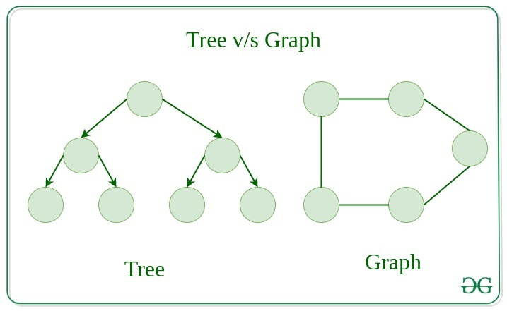

- Tree 2.Graph

Algorithm to Traverse elements from an Array:-
1
We have to access or traverse all the elements from this array with the help of algorithm we have to create a program.
3
2

4

Algorithm Title:-
[Traversing of elements from array. Where “d” is the name of array and “N” is the number of elements in the array. According to Linear]
Step 1:- Set k=1
Step 2:- Repeat while k<=N
Step 3:- Write d[k]
Step 4:- Set k=k+1
[End of step 2 loop]
Step 5:- Exit
- Program of Traversing data from an Array (Linear):-
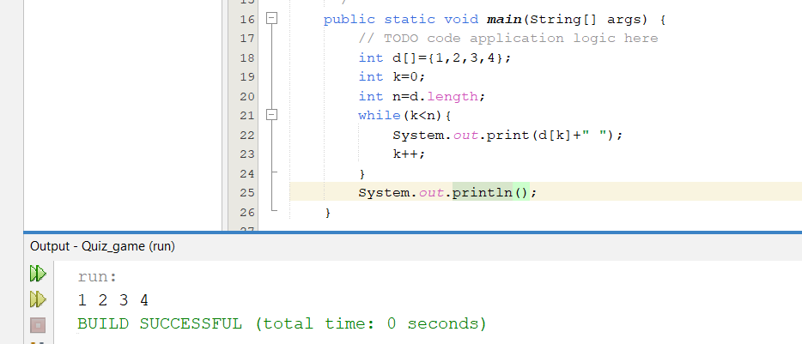

Algorithm to search location of desired element from an Array:-

We have to search the location of desired element from the array.
A
B
C
D

Algorithm Title:-
[Searching location of desired element from an array according to Linear. Where “d” is the name of array and “N” is the number of elements in the array].
Step 1:- Set k=1 AND loc=0 AND item= “C”
Step 2:- Repeat while k<=N
Step 3:- if d[k]== item THEN set loc=k AND return
[End of if]
Step 4:- Set k=k+1
[End of step 2 loop]
Step 5:- WRITE loc
Step 6:- Exit
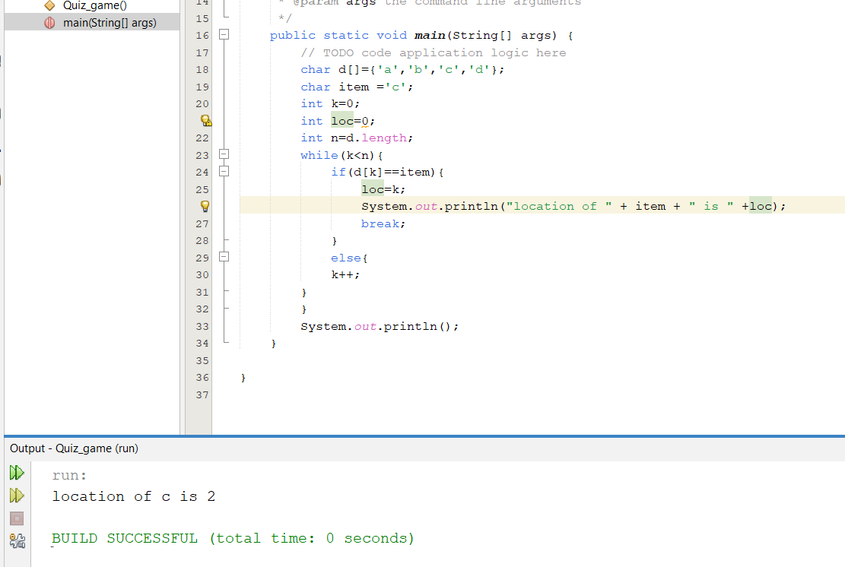
- Program of searching desired element from an Array (linear search) :-

Time Complexity of Algorithms:-
- There can be three kind of complexities in the program:-
  - Worst
These are represented by “Asymptotic notation”.
  - Best
  - Average
- Asymptotic Notations:-
- Big O → Worst Case
- Big Ω(Omega) → Best Case
- Big Θ(Theta) → Average Case
Note:- These all can be represented with Big O also and time complexity depends on number of inputs and comparisons.
Example:-
Suppose we have created a program and it gets constant time to perform its functionality means it gets executed in 30 seconds every time you run it. It can be represented as O(1).
1
2
3
4
We have to search the location of largest element in the array according to linear.

Algorithm to search location of largest element from an Array:-
Algorithm Title:-
[Searching location of largest element from an array according to Linear. Where “d” is the name of array and “N” is the number of elements in the array].
Step 1:- Set k=1 and loc=0 and max = d[0]
Step 2:- Repeat while k<=N
Step 3:- if d[k] > max THEN set loc =k
[End of if]
Step 4:- Set k=k+1
[End of step 2 loop]
Step 5:- Write loc
Step 6:- Exit

- Program of searching largest element from an Array:-
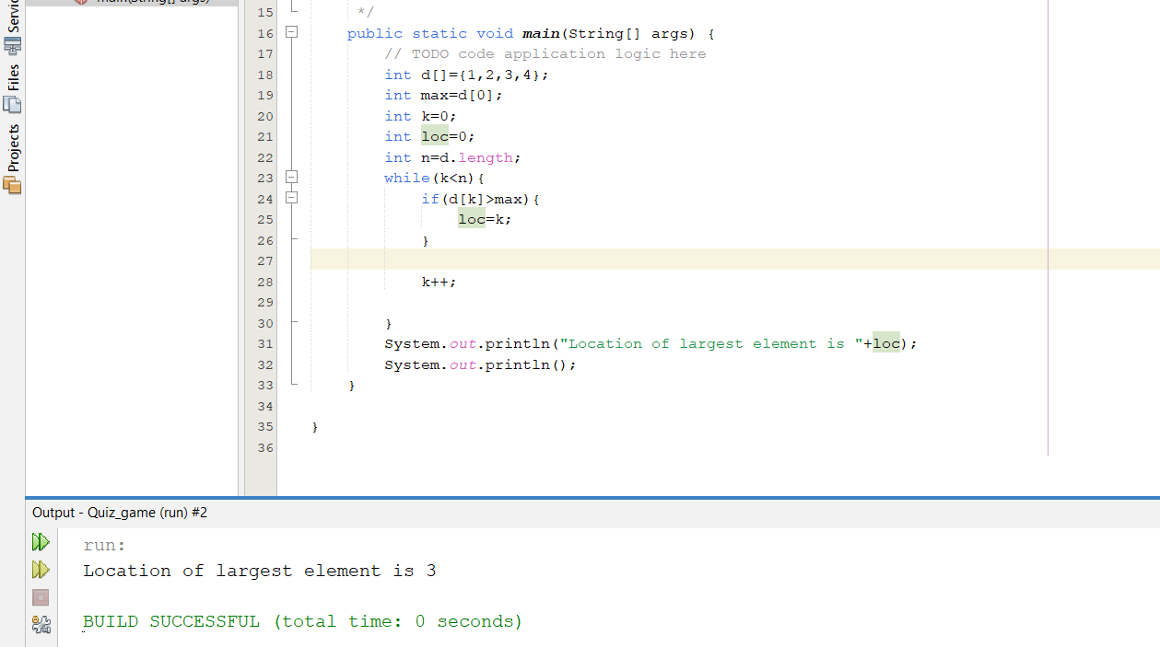

Binary search:-
- Binary search is an efficient algorithm used in Data Structures and Algorithms (DSA) to find the position of a target value within a sorted array or list. It works by repeatedly dividing the search space in half, which makes it much faster than linear search.
Note:- The array must be sorted to apply binary search.
1
2
3
4
We have to search desired element in the array according to Binary search.

Algorithm to search desired element from an Array(Binary Search):-

Algorithm Title:-
[Searching desired element from an array according to Binary search. Where “d” is the name of array and “N” is the number of elements in the array].
Step 1:- SET beg=1 AND end=d.length
Step 2:- SET mid= (beg+end)/2
Step 3:- Repeat while beg<end AND item !=d[mid]
Step 4:- if item<d[mid] THEN SET end=mid-1
Else
SET beg=mid+1
[End of if]
Step 5:- SET mid=(beg+end)/2
[End of step 3 loop]
Step 6:- if item == d[mid] THEN WRITE d[mid] AND exit
- Program of searching desired element from an Array (binary search) :-
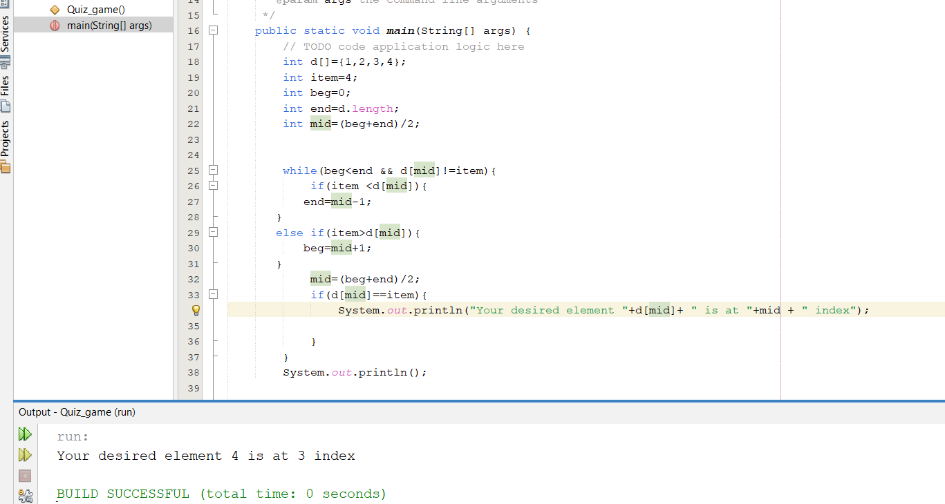

Algorithm to insert desired element in an Array:-
3
4
2
5
We have to insert desired element in the array according to Binary search. Suppose at position 2 we have to insert 5.
1
To this
From this
1
2
3
4

Algorithm Title:-
[inserting desired element in an array according to Linear. Where “d” is the name of array and “N” is the number of elements in the array and item is the desired value to insert].
Step 1:- SET k=N AND loc=2
Step 2:- Repeat while k>loc
Step 3:- SET d[k] = d[k-1]
Step 4:- Set k=k-1
[End of step 2 loop]
Step 5:- SET d[loc]=item
Step 6:- Exit
- Program of inserting desired element in an Array(Linear):-
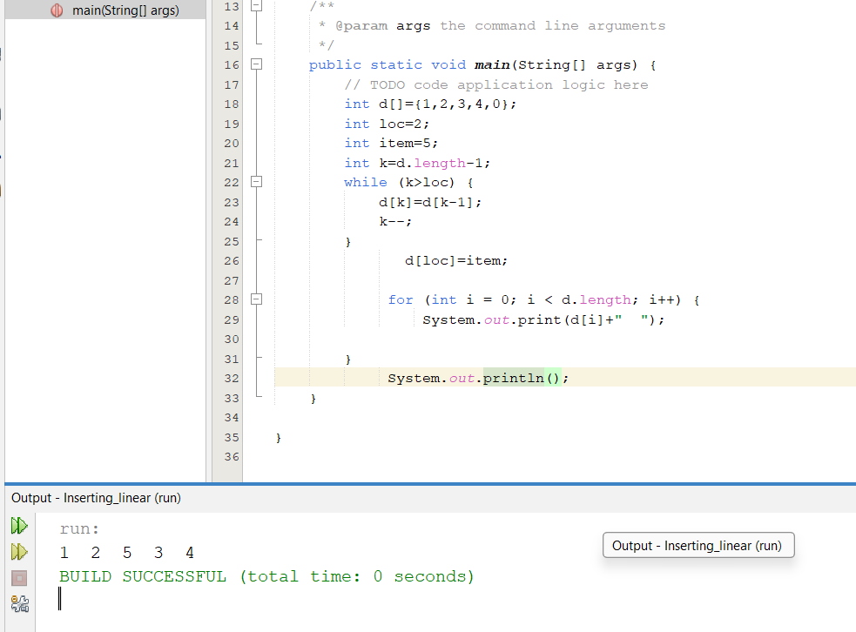

1
We have to delete desired element in the array according to Binary search. Suppose at position 2 we have to delete 5.
5
2
3
4
1
From this
To this
2

4
3

Algorithm to delete desired element in an Array:-
Algorithm Title:-
[deleting desired element in an array according to Linear. Where “d” is the name of array and “N” is the number of elements in the array].

Step 1:- SET k=N AND loc=2
Step 2:- REPEAT while loc<k-1
Step 3:- SET d[loc] = d[loc+1]
Step 4:- SET loc=loc+1
[End of step 2 loop]
Step 5:- Exit
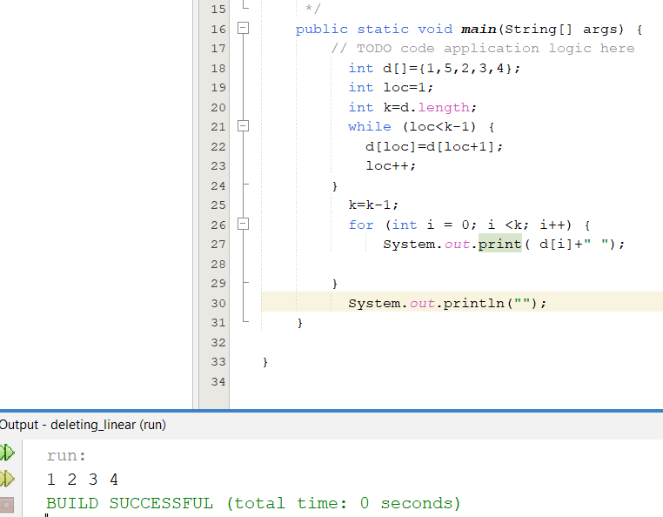
Program of deleting desired element in an Array(Linear):-

Sorting:-
- Rearranging the order of array either ascending or descending is called sorting.

3
4
5
We have to sort array according to Bubble Sort.
1
2
5
1
2
3
4

From this
To this

Bubble Sort:- It repeatedly bubbles the maximum element to the end of the array by comparing adjacent elements and swapping them if they are in the wrong order. Its time complexity is O(n²).
- adjacent refers to two elements in a list that are next to each other. For example, in the array [3, 5, 2, 1], the adjacent pairs are:
- (3, 5)
- (5, 2)
- (2, 1)

Algorithm to sort an Array through Bubble Sort:-
Algorithm Title:-
[Sorting an array according to According to Bubble Sort. Where “d” is the name of array and “N” is the number of elements in the array].
Step 1:- SET k=1
Step 2:- REPEAT while k<N
Step 3:- SET j=1
Step 4:- REPEAT while j<N-k
Step 5:- if d[j]>d[j+1] THEN
[Interchange]
[End of if structure]
Step 6:- SET j=j+1
Step 7:- [end of Step 4 loop]
Step 8:- SET k=k+1
[end of Step 2 loop]
Step 9:- Exit
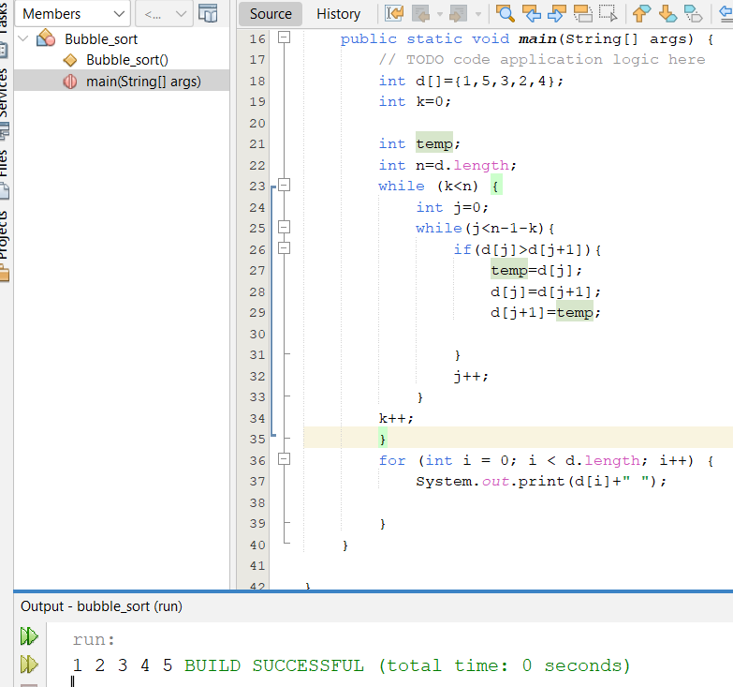
- Program of sorting an Array(Bubble Sort ):-

From this
To this
1
2
3
5
1
2
3
4
We have to sort array according to Selection Sort.
5
4

Selection Sort:- it is a sorting algorithm that repeatedly finds the smallest element from the unsorted portion of an array and swaps it with the current element in each iteration until the array is sorted.

Algorithm to sort an Array through Selection Sort:-
Algorithm Title:-
[Sorting an array according to According to Selection Sort. Where “d” is the name of array and “N” is the number of elements in the array].
Step 1:- SET k=1
Step 2:- REPEAT while k<N
Step 3:- REPEAT FOR j=k+1 TO N
Step 4:- if d[k]>d[j] THEN
[Interchange]
[End of if structure]
Step 5:- SET j=j+1
[End of loop Step 3]
Step 6:- SET k=k+1
[end of Step 2 loop]
Step 7:- Exit
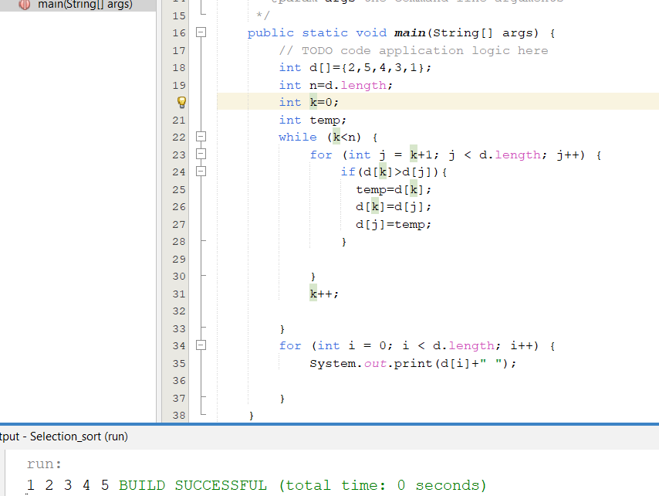
- Program of sorting an Array(Selection Sort ):-

Insertion Sort :- It is a simple sorting algorithm that works by taking one element from the list at a time and inserting it into its correct position in a sorted portion of the list.

Algorithm to sort an Array through Insertion Sort:-
Algorithm Title:-
[Sorting an Array Using Insertion Sort. Where "d" is the array, "N" is the number of elements in the array, and "item" refers to the element being inserted into its correct position.].
Step 1:- SET k=2
Step 2:- REPEAT while k<=N
Step 3:- SET p=k-1 AND item = d[k]
Step 4:- REPEAT while p>0 AND item <d[p]
Step 5:- d[p+1] =d[p]
Step 6:-SET p=p-1
[End of step 4 loop]
Step 7:- SET d[p+1] =item
Step 8:- SET k=k+1
[end of Step 2 loop]
Step 9:- Exit

- Program of sorting an Array(Insertion Sort ):-
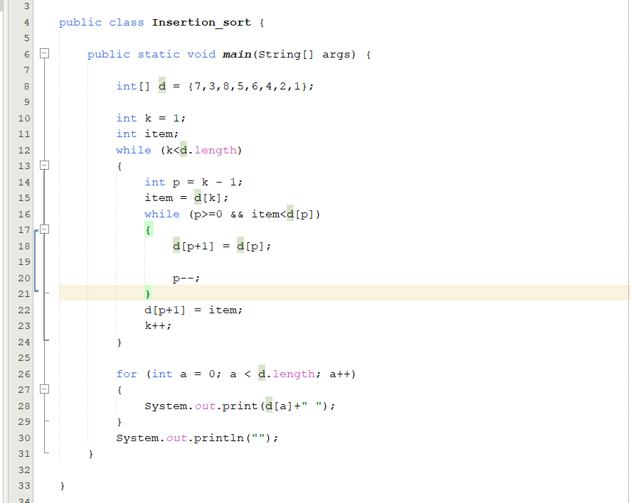

Linked List
Linked List:- It is a linear data structure in which elements are accessed according to pointer address. Each element has address of another element.
- There are two types of Linked List.
  - One Way Linked List
  - Two Way Linked List
One Way/Singly Linked List:- Every element has address of the next element.
Here B holds the address of 2 means “C” and A holds the address of 1 means “B” and C holds null means “No next value now”. Holding the address means the next output will be that node.
2
1
∅
C
A
B

Algorithm to Traverse data from an Array(Linked List):-
Algorithm Title:-
[Traversing of elements from array according to Linked List. Where “d” is the name of array, “link” is the name of another array which holds the addresses. and “N” is the number of elements in the array.]
Here each node has the address of next node. Here “E” holds the address “Null” because there is no next element after E.
2
5
4
1
∅

B
A
E
D
C

Here start variable is assigned 3 because we have to start our traversing from 3rd position so that I may get the output I want “ABCDE”

Step 1:- SET start=3
Step 2:- REPEAT while start != ∅
Step 3:- Write d[start]
Step 4:- SET start=link[start]
Step 5:- [End of step 2 loop]
Step 6:- Exit
- Program of traversing an Array(Linked List ):-
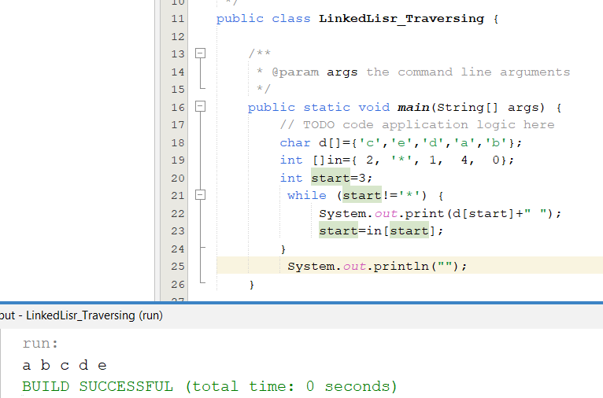

Algorithm to insert elements in an Array(Linked List):-
Algorithm Title:-
[Inserting elements in an array according to Linked List. Where “d” is the name of array, “link” is the name of another array which holds the addresses, insert is the name of another array which holds the values those are we want to insert in array and “N” is the number of elements in the array.]

D

E

C
*
A
*

B
Here each node has the address of next node. Here “*” means at that address the element is to be inserted.

2
4
5
∅

1
The elements being inserted are “D” and “E” and I want the output as “ABCDE”.

Step 1:- SET start=3 and var=1
Step 2:- REPEAT while start != ∅
Step 3:- if d[start] == ‘*’
THEN SET d[start]= insert[start]
AND AND var=var+1
[End of If structure]
Step 5:- WRITE d[start]
Step 6:- SET start=link[start]
[End of step 2 loop]
Step 7:- Exit

- Program of Deleting elements in an Array(Linked List ):-
Algorithm Title:-
[Deleting elements in an array according to Linked List. Where “d” is the name of array, “link” is the name of another array which holds the addresses, dlt is the name of another array which holds the values those are we want to Delete from array and “N” is the number of elements in the array.]

D

E

C
D
A
E

B
Here each node has the address of next node. Here “DE to *” means at that address the element is to be deleted

2
4
5
∅

1
The elements being deleting are “D” and “E” and I want the output as “ABC**”.

Step 1:- SET start=3 and var=1
Step 2:- REPEAT while start != ∅
Step 3:- if d[start] == dlt[var]
THEN SET d[start]= ‘*’
AND var=var+1
[End of If structure]
Step 5:- WRITE d[start]
Step 6:- SET start=link[start]
[End of step 2 loop]
Step 7:- Exit

